**HOSPITALITY**

In the hospitality industry, these terms are commonly used in revenue management and hotel performance metrics:

1. **DevPar (Revenue per Available Room Development)**

This is not a standard hospitality metric but might be used in specific contexts to indicate revenue performance in development projects.

1. **ADR (Average Daily Rate)**



It represents the average rental income per paid occupied room in a hotel.

1. **Occupancy (Occupancy Rate)**

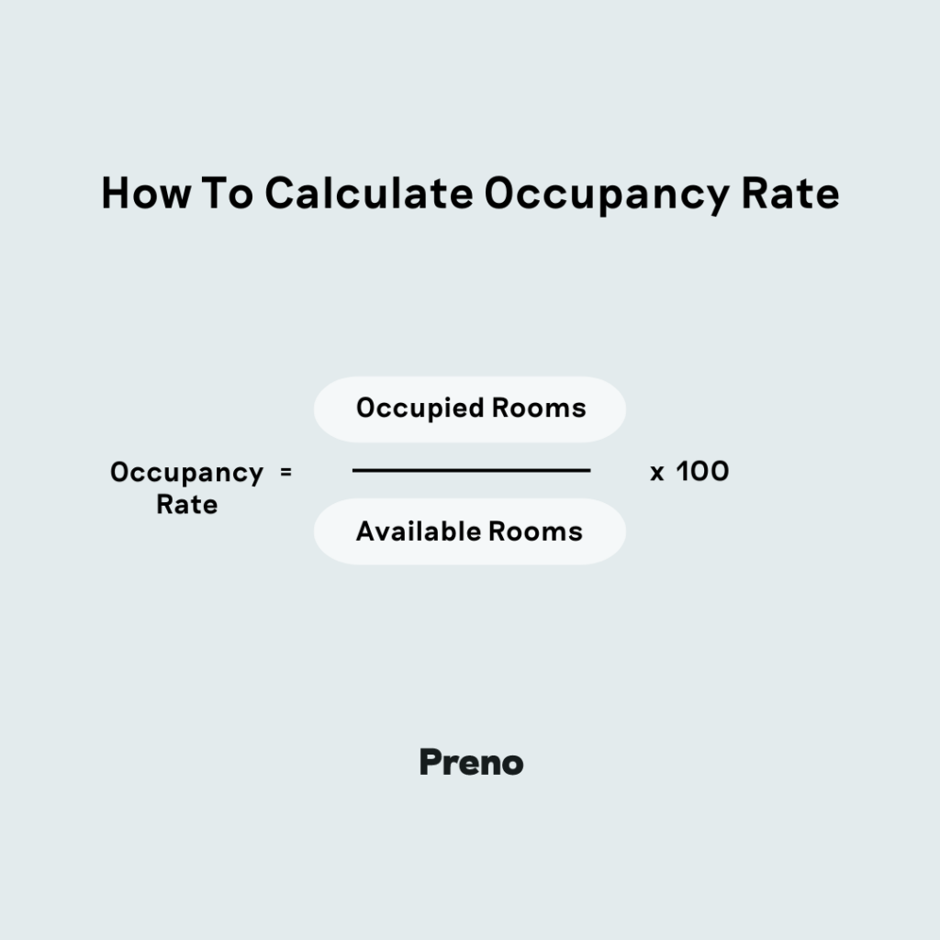

It measures the percentage of available rooms that are occupied during a given period.

1. **SRN (Sold Room Nights)**

This refers to the total number of rooms that have been sold or occupied over a specific period.

1. **DSRN (Demand Sold Room Nights)**

This metric is used in forecasting and revenue management, referring to the number of room nights sold based on demand predictions.

1. **URN (Utilized Room Nights)**

The total number of rooms that were actually occupied during a specific period.

1. **BRN (Booked Room Nights)**

The total number of room nights that were reserved/booked in advance, including future reservations.

1. **Realization**

Realization Rate=(URN/BRN) * 100

**Level 1 Analysis (High-Level Summary & Aggregated Data)**

* This is the initial stage of data analysis, focusing on broad, high-level insights without diving into deep details.
* It provides a general overview of key metrics like:
  + Patient volume
  + Bed occupancy rate
  + Average length of stay (ALOS)
  + Admission & discharge trends
  + Revenue by department
* It helps in identifying overall hospital performance.

Example:

* A hospital wants to analyze monthly performance.
* Level 1 Analysis shows:
  + Total patients admitted = 3,000
  + Bed Occupancy Rate = 85%
  + Average Length of Stay (ALOS) = 4.5 days
  + Revenue breakdown:
    - Emergency: $500,000
    - Surgery: $1.2 million
    - Outpatient: $700,000

Conclusion: The hospital sees that occupancy is high and surgery contributes the most revenue, but no deep cause analysis is done yet.

**Level 2 Analysis (Detailed, Root Cause & Performance Optimization)**

* **Digs deeper** into the data from Level 1.
* Focuses on **root causes, correlations, and patterns** to **optimize hospital performance**.
* Uses **granular data** like:
  + **Patient demographics (age, gender, diagnosis type)**
  + **Disease patterns & seasonal trends**
  + **Doctor-wise & department-wise performance**
  + **Readmission rates & mortality rates**
  + **Cost analysis per patient**

#### **Example:**

Continuing from the previous Level 1 example:

* The hospital sees that the **ALOS is 4.5 days**, but wants to **analyze it by department**.
* **Level 2 Analysis Finds:**
  + **Emergency ALOS** = 2.1 days
  + **Surgery ALOS** = 6.8 days
  + **ICU ALOS** = 12.5 days
  + **Common Reason for Long Stays:** High readmissions in post-surgery patients.
  + **Surgical Readmission Rate** = 15% (higher than industry average).

**Conclusion:**

* **Root Cause Identified:** High readmissions due to post-surgical infections.
* **Actionable Insights:** Improve post-op care, introduce infection control measures, optimize discharge planning.

**STAR Schema**

